Dr. Aliaa El-Husseiny Mohamed Mohamed Daifalla
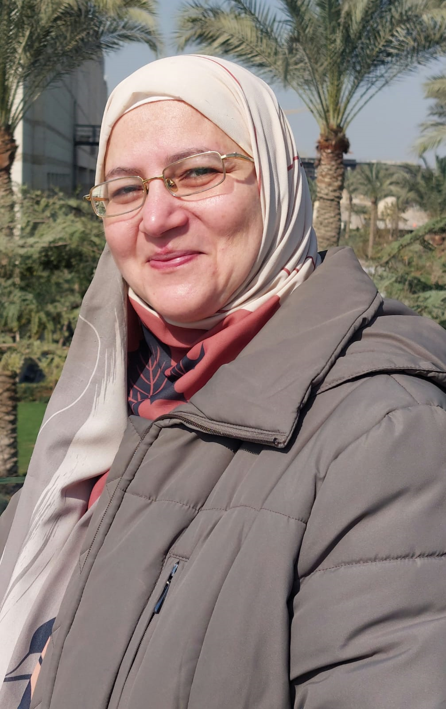
Date of birth: 1/1/1975
Nationality: Egyptian

Home/Mailing Address: 26 Dawlatian street, Aghakhan, Nile Corniche, Cairo
Tel: Home 00201960203, Mobile 01552877890 Egypt

Email Address: aliaaderm@yahoo.com
aliaa.daifalla@fmed.bu.edu.eg

Employment / Jop title: Assistant Professor of Dermatology, Venereology and Andrology, Faculty of Medicine, Benha University, Egypt. (2023-present)

Qualifications:
-Medical school: graduated with excellence from Faculty of Medicine,
Benha University, Egypt. (30/12/1998)
-Master Degree of Dermatology and Andrology: from Faculty of Medicine, Benha University, Egypt. (30/9/2005)
-Fellowship in basic dermatology research, University of Pennsylvania, Pennsylvania, USA. (1/7/2010)
- MD Degree of Dermatology and Andrology: from Faculty of Medicine, Benha University, Egypt. (31/4/2013)

-Aesthetic Gynecology Professional Diploma, American Association of Continuing Medical Education, Egypt. (2019)
- Training of Trainers (TOT) certificate from the National Center for Training and Leadership, Supreme Council of Universities (SCU), Cairo, Egypt. (April 2024)
- Training of Trainers (TOT) certificate from the Canadian Training Center of Human Development (CTCHD), Cairo, Egypt. (June 2024)
- Fellowship in Health Professions Education by FAIMER, USA in partner with Ain Shams University, Egypt (ASU-MENA-FRI). (2023-2025)

Core skills:
- Professional dermatologist
- Laser and aesthetic dermatology experienced
- Organized clinical and academic research work
- Value professional integrity, and commitment to ongoing improvement
- Have strong critical thinking, and problem-solving skills
- Skilled at providing comprehensive patient care, patient and family education.
- Approach everything with positivity, innovation, and credibility
- Have team leader abilities, precise, and meticulous
- Fluent in Arabic, and English

Work experience:
- Dermatoses treated include:
- Atopic dermatitis, Eczema
- Cutaneous infections
- Fever with rash
- Drug eruption, erythema multiform, erythroderma
- Bullous diseases, purpura, vascuilitis
- Benign and malignant skin tumors
- CTDs
- Morphea, amyloidosis
- Psoriasis
- Urticaria
- Lichen planus
- Pruritis
- Acne, rosacea
- Alopecia areata

- The following dermatological procedures: skin biopsy, KOH examination, electrocautery, cryocautery, comedo extraction, chemical peeling, intradermal injection, Mesotherapy, PRP.
- Phototherapy: PUVA, NB-UVB
- Laser: Alexandrite, Q-switched Nd: YAG, IPL, and CO2 laser therapy.
- Non surgical threads lifting.
- Autologous Nanofat injection.

Teaching experience:
- Clinical rounds for undergraduate and postgraduate students in dermatology and andrology.
- Lectures, clinical rounds, group discussions, grand rounds, case-based learning and problem solving for postgraduate students in dermatology and andrology.
- Seminars, webinars, and workshops for Medical School Faculty on medical education: teaching methods, clinical education, assessment, and AI.

Research experience:
Research interest in basic dermatology, animal studies, epidemiology, HRQoL, clinical dermatology, dermoscopy, and female sexuality.
https://orcid.org/0000-0001-6971-8473

Specialty years of experience:
Over 20 years of experience in Dermatology, Venereology and Andrology (2000-present).
(References are available upon request)

